Elton John – Farewell Yellow Brick Road Tour
P&J Live, Aberdeen
Thursday 15th June 2023

We can’t wait to welcome you to P&J Live. Please see below for everything you need to know before arriving at the venue for Elton John’s show.

Event Information:
If using a digital ticket, prior to entry ensure you are logged in to your Ticketmaster app and open the ticket, 4G tends to slow down when big crowds gather.

Any existing physical tickets will scan for this show.

Event Timings:
Box office open: 17:00
Doors open: 18:00
Elton John: 19:30
Show End: 22:15

*All timings are approx. and are subject to change

Please note: there is NO SUPPORT – the show will start promptly at 19.30 with no interval.

Please note: roadworks will be carried out on the A96 Aberdeen to Inverurie Road West of Aberdeen Airport on this day. Lane closures and delays are expected so please leave in plenty of time.

We encourage you to arrive as close to doors opening to allow plenty of time to pass through our security checks.

Need to know:
- For more information about the show please visit our event listing here.
- It is no longer a legal requirement to wear face coverings in indoor settings in Scotland. We advise visitors to continue wearing masks in crowded indoor places, although not compulsory.
- Restrictions: Under 14’s must be accompanied by an adult (18+)
- If you feel uncomfortable, or unsafe during your time at the venue or wish to report any suspicious behaviour please text RAVEN on 0788 886 6337 to make our team aware.
- For your safety; large bags, backpacks of any kind or umbrellas, are not permitted into the venue.
- P&J Live is a cashless venue and we encourage all payments to be made using our contactless system for merchandise and refreshments.
- You will find our full venue Safety and Security Information here.

Our number one priority is making sure your visit is as safe and fun as possible. While the Scottish Government have removed many restrictions, we all still have a shared responsibility to help prevent the spread of Covid-19. Please familiarise yourself with our Covid-19 Venue Entry Information page here.

The Rocket Club
Join Elton John’s Rocket Club for regular giveaways, exclusive content and the latest updates from the Rocket Man. Join here!

Refreshments
All of our bars, kiosks and The Mill Coffee Shop, serving Costa Coffee will be in operation.

View Bar VIP Upgrade
This fantastic add-on will give you more time to enjoy yourself and cuts out the queues for refreshments. The upgrade includes a complimentary drink on arrival, early access, fast-track entry and access to the View Bar before, during and post-show. Add on a View Bar upgrade for Elton John by clicking here.

Venue VIP Premium Parking
Why not take advantage of our new Premium Parking Service? Arrive at the Venue via a dedicated fast-track vehicle entry lane, knowing that your parking space is reserved for you. Enter the Venue through the VIP fast entry lane and enjoy your Event knowing that you have a dedicated, fast exit route from our underground car park at the end of your visit. Add on this Premium Parking upgrade here.

Parking
This show is expected to be busy. There is LIMITED parking available on site, our Surface car park and our Sub-T car park, which is closest to the building. We encourage customers to arrive early to guarantee a space.

More information can be found here.
Stagecoach
Stagecoach will be operating its 727 Service between Union Square and P&J Live, running every 15-30 minutes. You can download the timetable here.

Additional busses will depart from Union Square to the venue on a dedicated PJ1 service from 17:50 the timetable can be found here. Timetable subject to change.

Busses will depart back into Aberdeen City Centre after the event is finished. These will depart from our taxi rank.

Park & Ride
Additional busses will depart from Craibstone Park & Ride to the venue on a dedicated PJ4 service from 18:15, the timetable can be found here. Timetable to subject to change. View a map of Craibstone Park and Ride here.

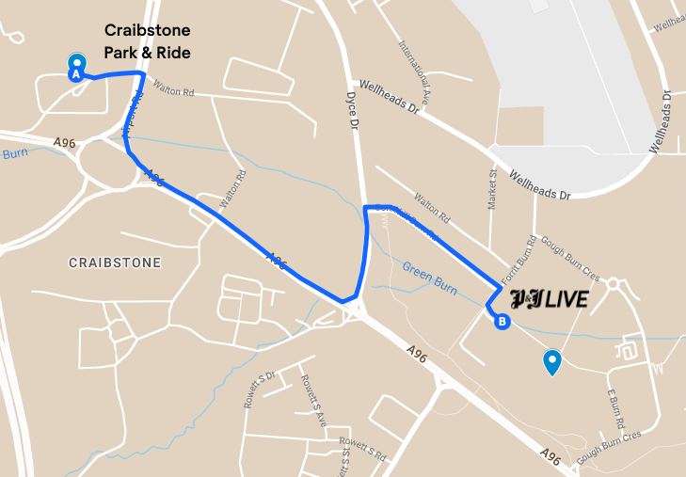

Address: Airport Rd, Dyce, Aberdeen AB21 0BZ

Make a day of it!
Fill your time before and after your event at P&J Live with an unforgettable meal, a comforting stay at one of the city's accommodations, or with even more activities.
Click here to start planning your trip.

Be kind
Please act responsibly, and be considerate to other visitors, giving them time and space where possible to move around the venue, and understand they may have different requirements to yours.

Most importantly
We really hope you enjoy the show and we are very much looking forward to seeing you back at P&J Live again soon.

